Documentation for Using Image_chart Library

# **Objective of The Library:**

The objective of this library is to use bar graph with user customized image more than ones in a single webpage.

# **Components of the library:**

This library is created with Angular.js module. There are two methods. But user can use only one method. The other method is for internal usage. The methods are

* myrunner(user usable method)
* init(internal method)

To use this “myrunner” method user have to pass required parameter. We will come to this part latter.

# **How to use:**

* Include the “angular_library.js” file in script tag of html
* Initialize the canvas with a canvas id.
* For showing multiple chart use multiple canvas with different id.

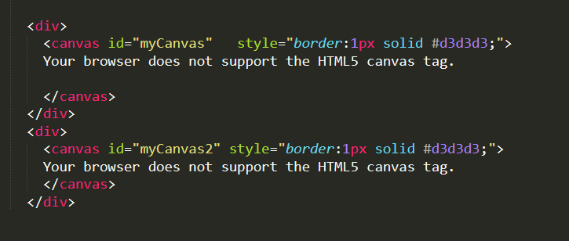

* Two use the library in angularjs create a module and a controller like the example file “angularscript.js” in the folder.
* Add the library module “demo” in your module dependency.
* Add the “library” parameter in your controller function.

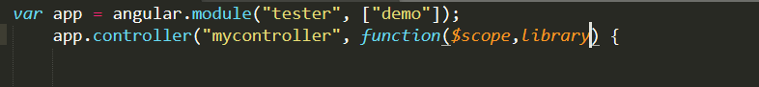

* Make Json Object array of required input.
* Make Json Object array of config for chart.

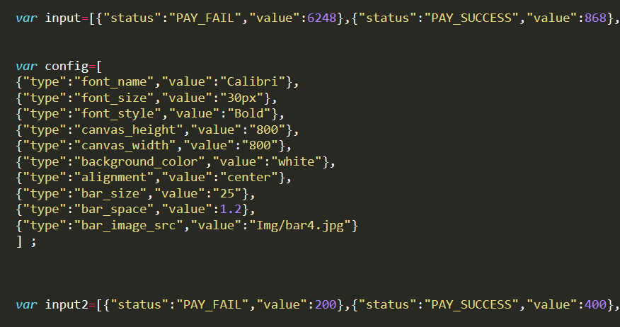

* To call the function of the library to draw graph do the following.

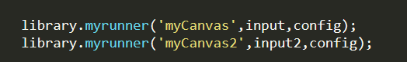

* Call the function myrunner by passing the canvas_id, datainput array and configuration array as function parameter.
* To view the chart instantly run the iconpat.html file from the folder.

# **Configuration Of the chart:**

By changing the configuration json, chart configuration can be changed.